
Tony Mecca

One-Sheet

Bio / Style / Genre
A troubadour that rocks - really! Philadelphia singer/songwriter Tony Mecca serves wisdom from deep in the inner city via a delicious storytelling based blueprint that inventively incorporates elements of Pop, Blues, Folk and plain old Rock 'n Roll. His stories fuse equal amounts of humor and sympathy to thoughtfully examine life experiences, personalities and real people dealing with ordinary and sometimes surreal circumstances. But plodding and tedious meditation are avoided at all costs, and rock ‘n’ roll sensibilities are injected at every opportunity to keep the proceedings vibrant, fun and quite distant from the music of most other artists residing in the singer/songwriter region. Only the slightest breeze from the swirling storm of humor, passion, hope, and reflection that emanates from these songs will send you rushing to introduce yourself to each and every one of the sumptuously eccentric characters that laugh, cry, love and cavort on the mean streets and avenues of Mecca’s beautiful urban American landscape.

Through live performances with his Heavy MeNtal Gypsys, and his steadily growing recorded output - Purple Monkeys (2003) / Princes of the New Dark Age (2005) / Hello, Goodbye & Everything in Between (2007) / Fun (2011) – Mecca has developed a loyal following in and around his home town that is gradually beginning to infiltrate other regions both nationally and abroad. His music has been labeled Classic Rock, Singer-Songwriter and Adult Contemporary among others. He calls it Urban American Heavy MeNtal. In reviews his songs and sound has been compared to Springsteen, Tom Petty, John Mellencamp, Jimmy Buffet and Cat Stevens. In a poll of his fans he was described as: “The bastard son of Huey Lewis and Joni Mitchell” – “The Who fronted by John Prine” – “The Working Man’s Wagner”. As anyone more than a little familiar with Tony Mecca’s music will tell you, his infectious raspy voice and hook laden melodies may initially confiscate most of your attention, but it is his sage commentary on the beauty and failings of the "human drill" that will eventually permeate your head, heart and soul.
.
_________________________________________________________________________________________________

Quote Edits

"What keeps me coming back to see Tony Mecca live is his songs. Tony is a solid songwriter with catchy melodies, thoughtful lyrics, and music that transports you to another place"
Cyndy Drue - Radio Personality/Event Reporter - Classic Rock WMGK (102.9 FM)

“Hello, Goodbye & Everything in Between” is the Everly Brothers, Bruce Springsteen and John Mellencamp from a blender, poured into melodic Americana via street-level tales of everyboy and everygirl. A great slice of Americana”
John Collinge / Progression Magazine #51

“Philadelphia balladeer Tony Mecca might best be described as an "undiscovered talent" who, in the hands of the right production team, could generate ripples on the Pop/AOR front. “Princes of the New Dark Age” is rootsy pop a la Bruce Springsteen/Billy Joel/Tom Petty, etc., that is melodically accomplished, catchy and fun to listen to” - John Collinge / Progression Magazine #50

“Mecca’s set on Saturday (3/22/08) – 22 songs in all clocking in at 2 hours - was filled with pleasant, easy on the ears music that deserves a shot with a wider audience. I recommend giving "Hello Goodbye & Everything In Between" a listen, an excellent album and one of the more underrated bodies of music I’ve listened to in the past year - Eric Cholminski (Blog-A Night at Cookies)
_________________________________________________________________________________________________

www.TonyMeccaMusic.com / TonyMecca@TonyMeccaMusic.com

P.O. Box 11902, Philadelphia, PA 19145 / 267-242-9276
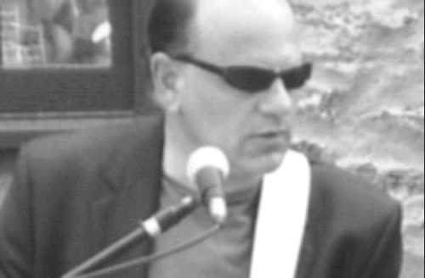
Tony Mecca

Artist Profile

A troubadour that rocks - really! Philadelphia singer/songwriter Tony Mecca serves wisdom from deep in the inner city via a delicious storytelling based blueprint that inventively incorporates elements of Pop, Blues, Folk and plain old Rock 'n Roll. His stories fuse equal amounts of humor and sympathy to thoughtfully examine life experiences, personalities and real people dealing with ordinary and sometimes surreal circumstances. But plodding and tedious meditation are avoided at all costs, and rock ‘n’ roll sensibilities are injected at every opportunity to keep the proceedings vibrant, fun and quite distant from the music of most other artists residing in the singer/songwriter region. Only the slightest breeze from the swirling storm of humor, passion, hope, and reflection that emanates from these songs will send you rushing to introduce yourself to each and every one of the sumptuously eccentric characters that laugh, cry, love and cavort on the mean streets and avenues of Mecca’s beautiful urban American landscape. As anyone more than a little familiar with Tony Mecca’s music will tell you, his infectious raspy voice and hook laden melodies may initially confiscate most of your attention, but it is his sage commentary on the beauty and failings of the "human drill" that will eventually permeate your head, heart and soul.

So what do you think of my Tony Mecca “Bio/Article?”
I’m flattered and a little embarrassed.

What can you tell us about yourself?
I was born and still live in Philadelphia. I’m married and have five kids and six dogs (currently). I own the Opera House Recording Studio. I miss Frank Zappa terribly.

What style of music do you play?
Urban American Heavy MeNtal

What’s that?
Storytelling Rock Music slightly altered by elements of Root, Pop and Folk -
I’ve also heard my music called “Singer/Songwriter Rock” - “Blues Rock” -
“Adult Contemporary” and “Classic Rock”

Who do people say you sound like?
In reviews I’ve gotten Springsteen, Petty, Mellencamp, XTC, John Prine, Cat Stevens, and Leonard Cohen among others. In a recent email poll through our web site here’s what our friends and fans said:

- “The bastard son of Huey Lewis and Joni Mitchell”
- “The Who fronted by John Prine”
- “Dylan with a sack - and a sense of humor”

Where have you been and where are you going?
I’ve recorded four CD’s - Purple Monkeys (2003) / Princes of the New Dark Age (2005) / Hello, Goodbye & Everything in Between (2007) / FUN (2011) and I’m back out playing the bars – Over the past few years I’ve signed several of my songs with various publishing companies throughout the country. While I’m not disappointed being a “local artist” and only playing in the Philadelphia area, I do live in hope that my songs will someday reach a larger audience – Perhaps via higher profile recording artists.

------------------------------------------------------------------------------------------------------------------------------------------------------------------

www.TonyMeccaMusic.com / TonyMecca@TonyMeccaMusic.com

P.O. Box 11902, Philadelphia, PA 19145 / 267-242-9276

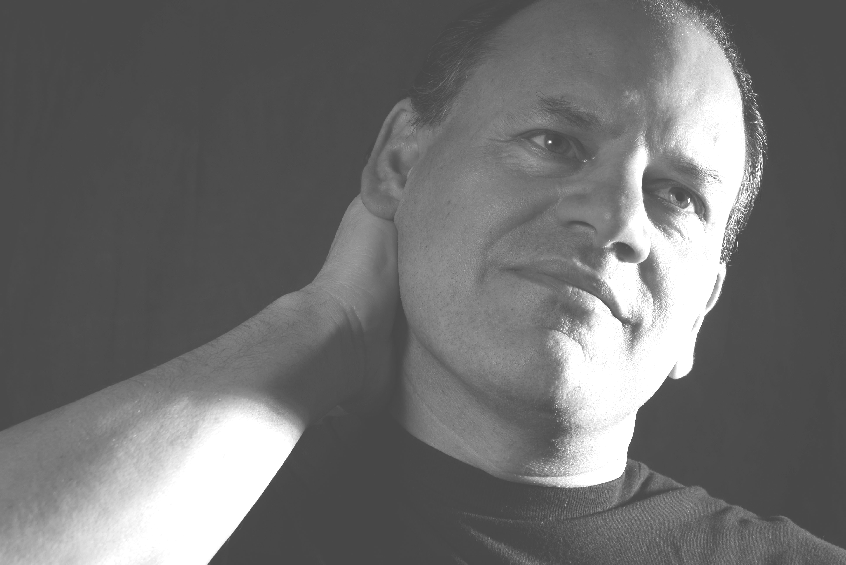

Tony Mecca

Reviews / Quotes

Hello, Goodbye & Everything in Between (2007) – Tony Mecca

“Hello, Goodbye & Everything in Between” is the Everly Brothers, Bruce Springsteen and John Mellencamp from a blender, poured into melodic Americana via street-level tales of everyboy and everygirl. Genuine innocence - whatever became of it? Mecca and friends turn back the clock keeping it sweet and simple via tunes like "An American Kid," "Annie Walks Through Town," "The Night We Danced" - pretty much any of the 22 tracks offered here (Take your pick.). It’s easy to relate to the protagonists populating Mecca's sweet tales of love and longing, work, partying and watching life play itself out because after all, they’re just you and me. A great slice of Americana”.
John Collinge / Progression Magazine #51

“Beautiful east coast romanticism! “Hello, Goodbye & Everything in Between” recounts tales of life and love in the blue-collar South Philadelphia Italian-Irish neighborhood where he grew up. The lyrics are reminiscent of Springsteen or perhaps even Leonard Cohen but with a gritty Philly twist, whereas the music itself is ‘Americana rootsy’. Mecca's many years of writing and performing have culminated in a wonderful effort. Highly recommended”!
Jason MacMillan / Amazon.com / October 12, 2007

Princes of the New Dark Age (2005) – Tony Mecca

“Philadelphia balladeer Tony Mecca might best be described as an "undiscovered talent" who, in the hands of the right production team, could generate ripples on the Pop/AOR front. This is rootsy pop a la Bruce Springsteen/Billy Joel/Tom Petty, etc., that is melodically accomplished, catchy and fun to listen to. In fact, the material on the self-produced “Princes of the New Dark Age” is strong enough to question why some label hasn't snagged the guy and given him a shot at wider audiences. Pick most any track from this album and you'll find a ditty worth sinking your teeth into. A gem like "Say Goodbye to Judas," for instance, might leave you wondering what radio station you heard it on first”.
John Collinge / Progression Magazine #50

Purple Monkeys (2003) – Tony Mecca

“Infused with equal amounts of humor and sympathy, this stunning new collection of “Purple Monkeys” thoughtfully examines everyday people dealing with ordinary and surreal life circumstances, and serves notice that Tony Mecca has once again taken his rightful place among the area’s elite singer/songwriters. Beautifully original”.
Joe Vanik / Philly Music Reader / Spring 2004

------------------------------------------------------------------------------------------------------------------------------------------------------------------

www.TonyMeccaMusic.com / TonyMecca@TonyMeccaMusic.com

P.O. Box 11902, Philadelphia, PA 19145 / 267-242-9276



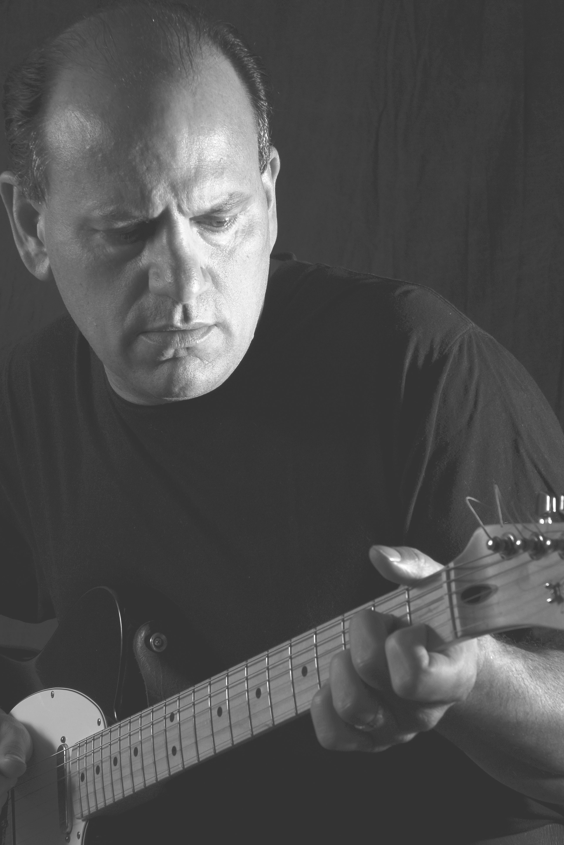

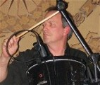
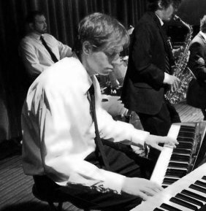
Tony Mecca

Live

What We Play
We normally play a set of all original music from our 4 CD’s that can run from 30 minutes to 2 hours depending on the club/bar owner’s needs/requirements – We are 2 voices, 1 acoustic guitar, 1 electric guitar, 1 bass, 1 keyboard and 1 drums. We also perform as a trio or other …
_________________________________________________________________________________________________

Our Basic Requirements
> Stage - Should comfortably accommodate 3-6 human beings
> PA - 6 inputs - 2 vocal mics with at least two boom stands - 2 inputs with direct boxes (if available) for acoustic guitar (which solely utilizes PA for amplification) and keyboard direct signal (sound engineer may choose to also mic the electric guitar amp and bass amp)
> Monitor(s) - 1 or 2 but not imperative in small venues
> We can provide our own PA for the bar/club owners that want to try live music.

*For more information regarding our live show, please view our SONICBIDS EPK:

http://www.sonicbids.com/epk/epk.aspx?epk_id=153034
_________________________________________________________________________________________________

Where We’ve Played

Nov 6 2nd St Irish Society / Philly
Oct 16 Cookies Bar / Philly
Oct 8 Mojo 13 / Wilmington DE
Sep 13 Stogie Joe’s / Philly
Sep 8 The Adobe’ Cafe / Philly
Jun 18 Cookies Bar / Philly
Jun 5 Van Blunk’s / Philly
May 15 The North Star Bar / Philly
May 12 The Adobe’ Café / Philly
May 8 Orbit Gallery / Manayunk
May 3 Stogie Joe’s / Philly
Apr 23 JR’s Bar / Philly
Apr 14 The Adobe’ Café / Philly
Apr 5 Stogie Joe’s /Philly
Mar 13 Cookies Bar / Philly
Mar 6 JR’s Bar / Philly
Mar 1 Stogie Joe’s / Philly
Feb 20, 2010 The Krunch Inn / Philly
Dec 4 Cookies Bar / Philly
Oct 30 The North Star Bar / Philly
May 1 The Krunch Inn / Philly
Apr 18 Tappers Club / Philly
Mar 27 JR’s Bar / Philly
Mar 21 Cookie Bar / Philly
Feb 20 The North Star Bar / Philly
Jan 31, 2009 The Krunch Inn / Philly
Dec 5 The Krunch Inn / Philly
Nov 15 2nd St. Irish Society / Philly
Oct 18 The Stonehouse Pub / Philly
Sep 26 Epiphany Italian Festival / Philly
Aug 9 The North Star Bar / Philly
Aug 2 Bridgeton FOE / Bridgton, NJ
Jul 3 The North Star Bar / Philly
Jun 3 The North Star Bar / Philly
May 17 Cookies Bar / Philly
May 10 Orbit Gallery / Manayunk
Apr 26 The Krunch Inn / Philly
Apr 12 Orbit Gallery / Manayunk
Apr 10 Propper Brothers / Philly
Mar 22 Cookies Bar / Philly
Mar 15 JR's Bar / Philly
Mar 1 Second St. Irish Society / Philly
Feb 29 The Krunch Inn - Philly
Jan 26, 2008 Cookies Bar / Philly

_________________________________________________________________________________________________

www.TonyMeccaMusic.com / TonyMecca@TonyMeccaMusic.com

P.O. Box 11902, Philadelphia, PA 19145 / 267-242-9276

Tony Mecca

Discography

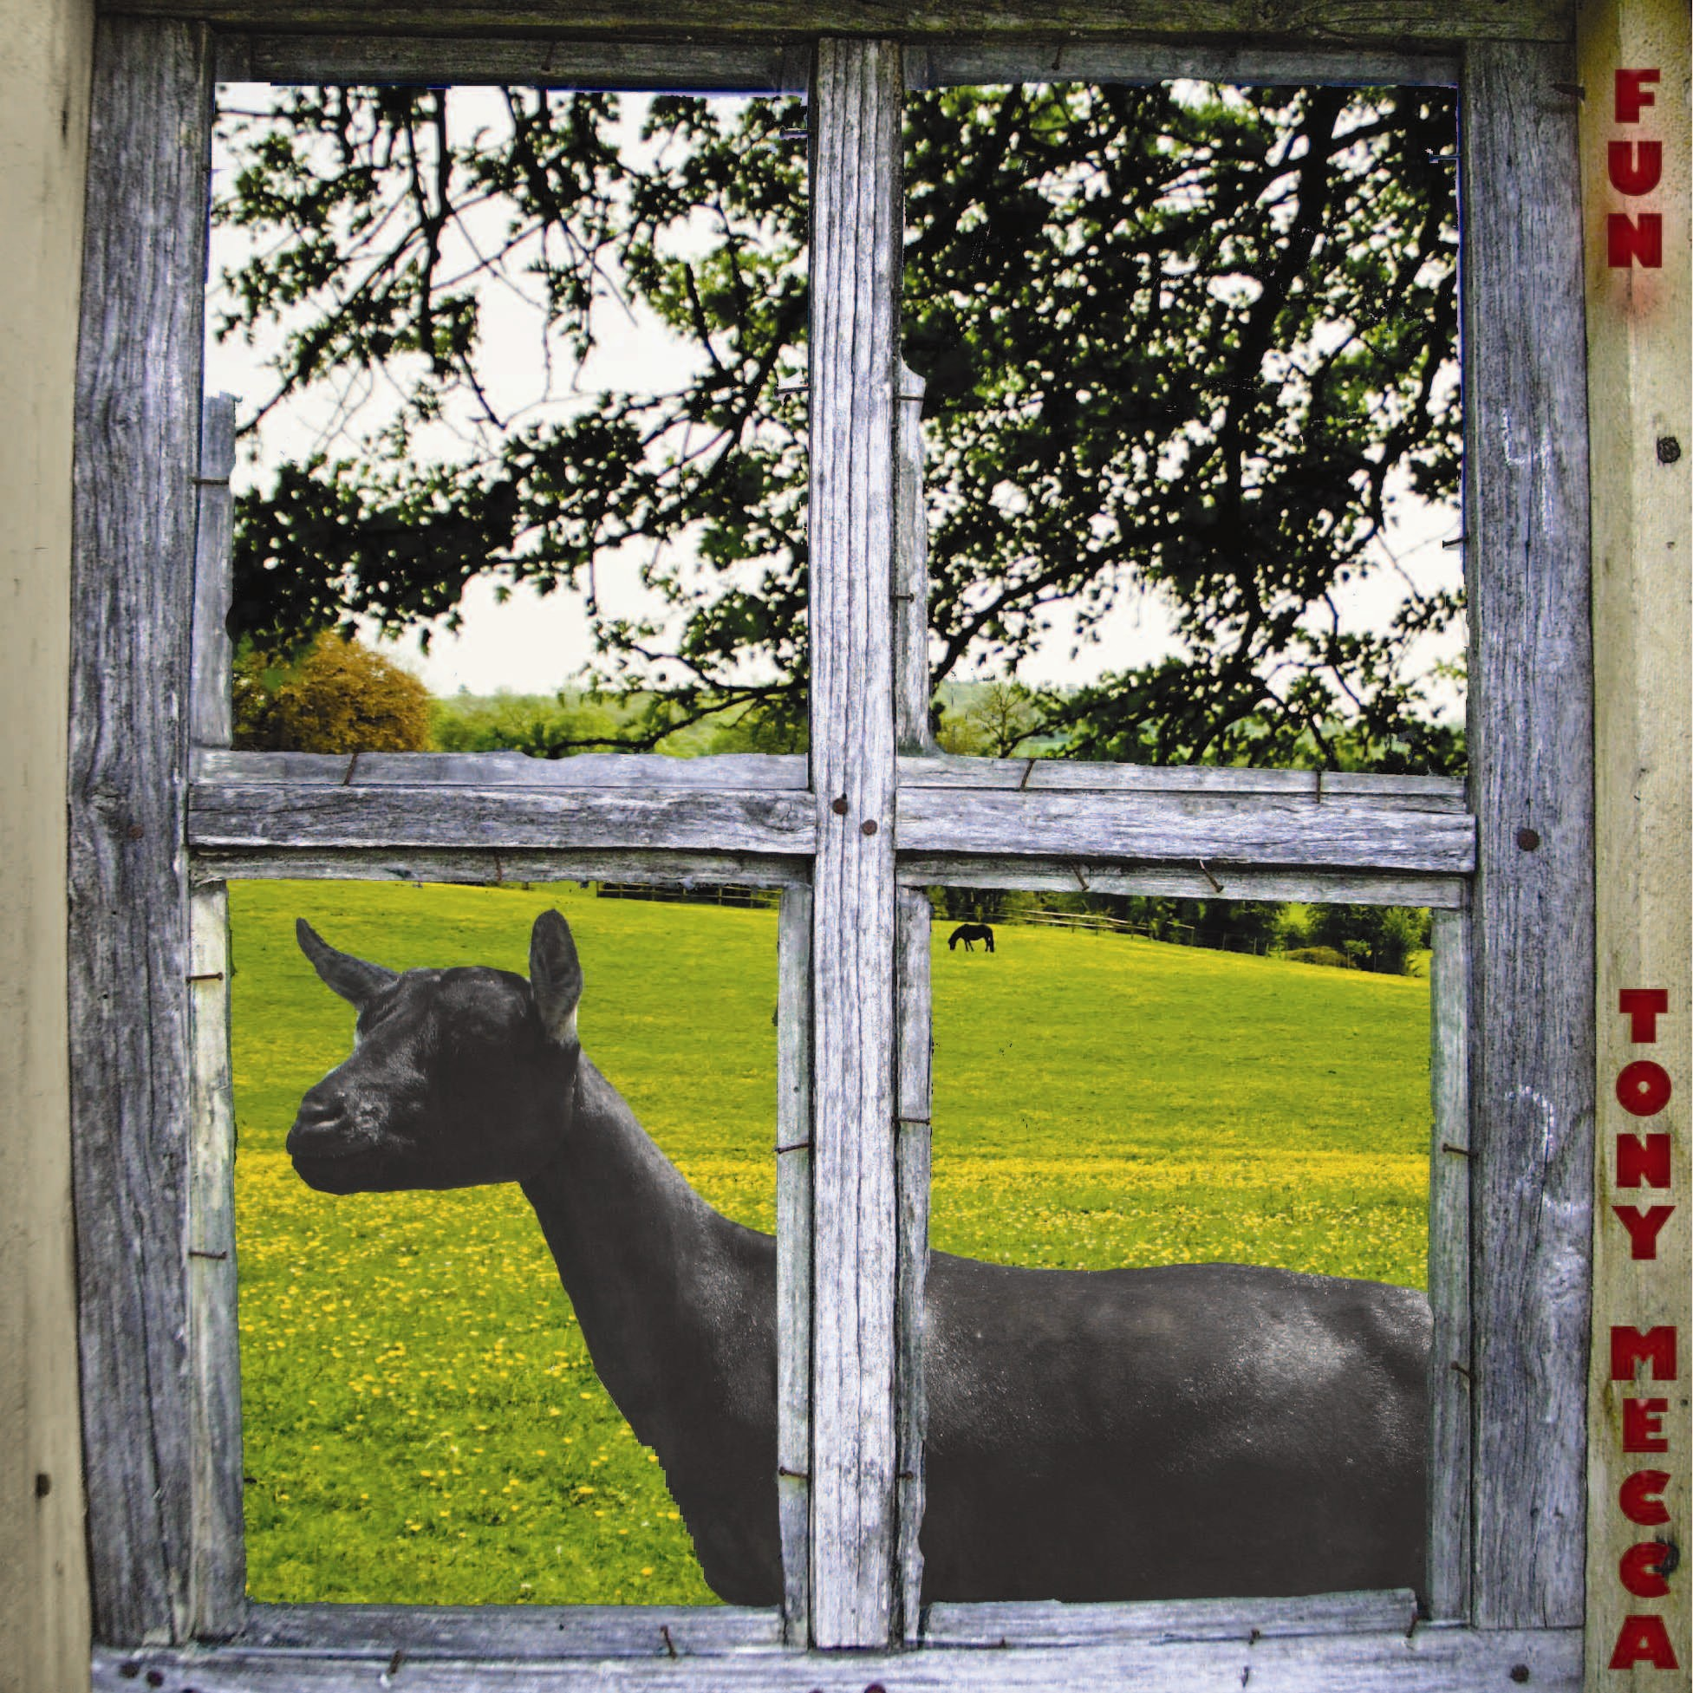
Fun (2011)

Urban Americana Records

14 songs (52:41) / Includes fully illustrated 16 page lyric booklet

$13.50
Bar Code: 884501426428

Rock / Urban Americana / Singer-Songwriter Rock / Blues Rock
________________________________________________

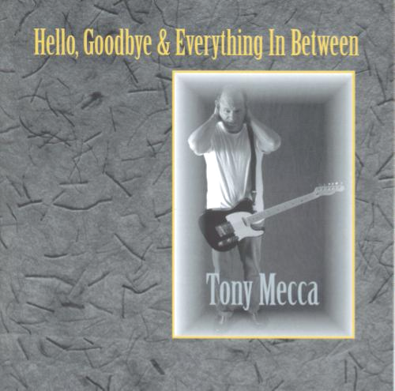
Hello, Goodbye & Everything in Between (2007)
Urban Americana Records / Outstanding Records

22 songs (75:38) / Includes fully illustrated 16 page lyric booklet

$11.99

Bar Code: 837101321044

Rock / Urban Americana / Singer-Songwriter Rock / Blues Rock
________________________________________________

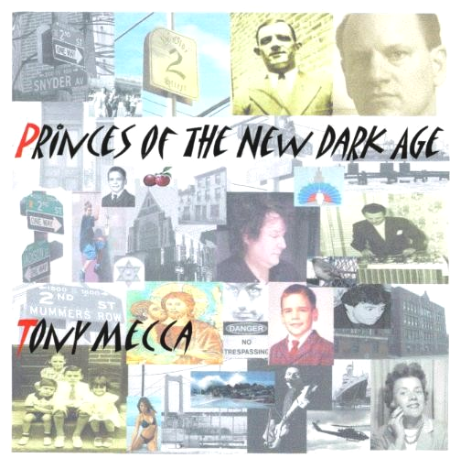
Princes of the New Dark Age (2005)

Outstanding Records

12 Songs (46:10)

Bar Code: 884502370010

$6.99 (Download Everywhere – CD via website)

Rock / Urban Americana / Singer-Songwriter Rock
________________________________________________

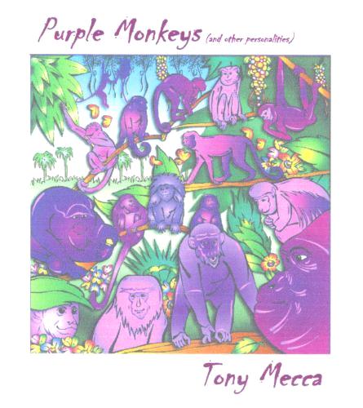
Purple Monkeys (2003)

Outstanding Records

10 Songs (47:12)

Bar Code: 884502147612

$6.99 (Downloads Everywhere – CD via website)

Rock / Urban Americana / Singer-Songwriter Rock
________________________________________________

CD’s – Downloads - Promotion Available On-Line:

www.TonyMeccaMusic.com - www.reverbnation.com/tonymecca - www.myspace.com/tonymeccamusic

www.cdbaby.com/Artist/TonyMecca - www.amazon.com/Tony-Mecca/e/B001LH2ZB8

“All AMI Jukeboxes”

